# **Project 7: Exploring the Impact of Emerging Technologies on Banking Operations and Security**

## AIM:

The aim of this analysis is to explore how emerging technologies such as mobile banking, predictive maintenance, behavioral biometrics, and blockchain impact banking operations and security. The analysis provides insights into transaction patterns, maintenance efficiency, authentication methods, and digital banking adoption trends.

## FEATURES:

**Table 1: Mobile Banking App Analytics**

* **User ID**: Unique identifier for each user.
* **Age**: Age of the user.
* **Gender**: Gender of the user ( Male, Female, Other).
* **Location**: User's location ( Urban, Suburban, Rural).
* **Account Type**: Type of bank account.
* **Transaction Count**: Number of transactions made.
* **Transaction Amount (in USD)**: Total amount of transactions
* **Login Frequency**: Frequency of logins.
* **Session Duration**: Duration of each session
* **Last Login**: Date of the last login (Date).
* **Device Type**: Type of device used ( Android, iOS, Other).
* **App Version**: Version of the mobile app
* **Customer Rating**: Rating given by the customer
* **Support Requests**: Number of support requests made.
* **Expenses Adoption (in USD)**: Expenses related to adoption

**Table 2: Predictive Maintenance for ATMs**

* **ATMID**: Unique identifier for each ATM.
* **Location**: ATM location ( Urban, Suburban, Rural).
* **Last Maintenance Date**: Date of last maintenance (Date).
* **Issue Reported**: Type of issue reported.
* **Downtime Hours**: Hours of downtime.
* **Maintenance Cost (in USD)**: Cost of maintenance.
* **Technician ID**: Identifier for the technician.
* **Predicted Failure Date**: Predicted date of failure (Date).
* **Component Replaced**: Whether a component was replaced (Yes, No).
* **Replacement Cost (in USD)**: Cost of replacement.
* **Next Maintenance Date**: Next scheduled maintenance date (Date).
* **ATM Status**: Current status of the ATM (Operational, Out of Service).
* **Error Logs**: Number of error logs.
* **Service Provider**: Service provider for the ATM.
* **Service Duration**: Duration of the service.

**Table 3: Behavioral Biometrics for Authentication**

* **Auth Session ID**: Unique identifier for each authentication session.
* **User ID**: Identifier for the user.
* **Auth Method**: Authentication method used (Voice Recognition, Gait Analysis, Keystroke Dynamics).
* **Timestamp**: Time of authentication attempt (Date Time).
* **Device Type**: Type of device used (Desktop, Laptop, Smartphone).
* **Location**: Location of the user.
* **Implementation Cost (in USD)**: Cost of implementation.
* **Security Level**: Level of security (Low, Medium, High).
* **Consultant Fees (in USD)**: Fees for consultants.
* **Training Costs (in USD)**: Training costs.
* **Maintenance Costs (in USD)**: Costs for maintenance.
* **Compliance Costs (in USD)**: Costs for compliance.
* **Auth Status**: Authentication status (Successful, Failed).
* **Error Logs**: Number of error logs.
* **Auth Time**: Time taken for authentication.

**Table 4: Blockchain Implementation for Security**

* **Transaction ID**: Unique identifier for each transaction.
* **User ID**: Identifier for the user.
* **Transaction Amount**: Amount of the transaction.
* **Transaction Type**: Type of transaction (Withdrawal, Transfer).
* **Timestamp**: Time of the transaction (Date Time).
* **Location**: Location of the transaction.
* **Security Cost (in USD)**: Cost of security.
* **Implementation Phase**: Phase of implementation (Planning, Deployment).
* **Security Level**: Level of security (Low, Medium, High).
* **Consultant Fees (in USD)**: Fees for consultants.
* **Training Costs (in USD)**: Training costs.
* **Maintenance Costs (in USD)**: Costs for maintenance.
* **Compliance Costs (in USD)**: Costs for compliance.
* **Transaction Status**: Status of the transaction (Successful, Failed).
* **Error Logs**: Number of error logs.

**Table 5: Digital Banking Adoption Analysis**

* **User ID**: Unique identifier for each user.
* **Age**: Age of the user.
* **Gender**: Gender of the user (Male, Female, Other).
* **Location**: User's location (Urban, Suburban, Rural).
* **Account Type**: Type of bank account.
* **Adoption Date**: Date of adoption of digital banking (Date).
* **First Transaction Date**: Date of the first transaction post-adoption (Date).
* **Adoption Channel**: Channel of adoption (Online, Phone, In-Branch, Other).
* **Transaction Count Pre-Adoption**: Number of transactions before adoption.
* **Transaction Amount Pre-Adoption (in USD)**: Total amount of transactions before adoption.
* **Transaction Count Post Adoption**: Number of transactions after adoption.
* **Transaction Amount Post Adoption (in USD)**: Total amount of transactions after adoption.
* **Customer Satisfaction Pre-Adoption**: Customer satisfaction rating before adoption.
* **Customer Satisfaction Post Adoption**: Customer satisfaction rating after adoption.
* **Expenses Adoption (in USD)**: Expenses related to adoption.

## METHODOLOGY:

1. **Data Cleaning and Preparation**:
   * Ensuring data accuracy, handling missing values, and standardizing formats.
2. **SQL Data Modeling**:
   * Creating relationships between tables for comprehensive querying and analysis.
3. **Dashboard Creation**:
   * Using Power BI to visualize key metrics and trends across the datasets.
4. **Data Analysis**:
   * Analyzing each dataset to extract meaningful insights.
5. **Interpretation of Results**:
   * Summarizing the findings and providing actionable recommendations.

# OUTPUT:

## Summary Dashboard

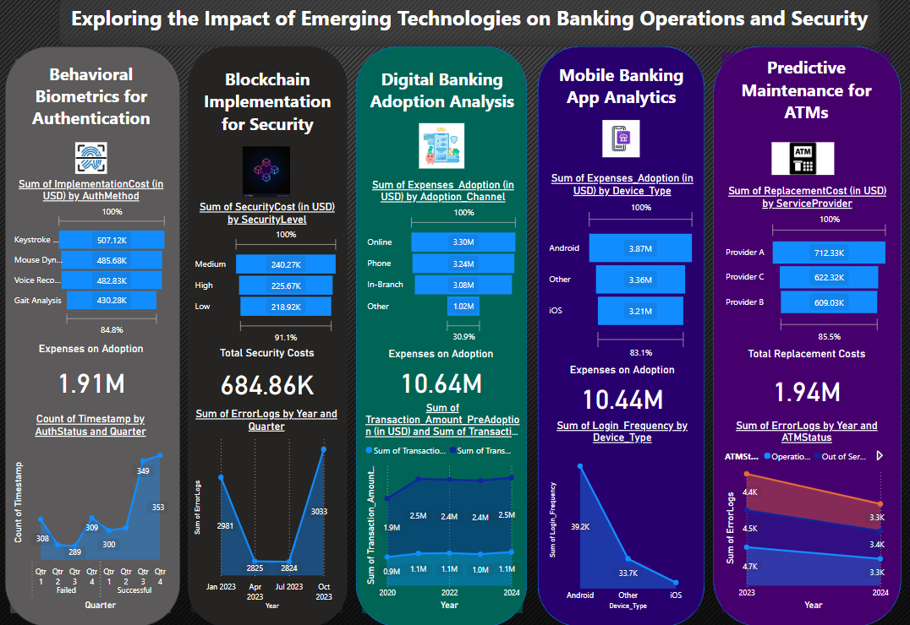

## 1. Behavioral Biometrics for Authentication

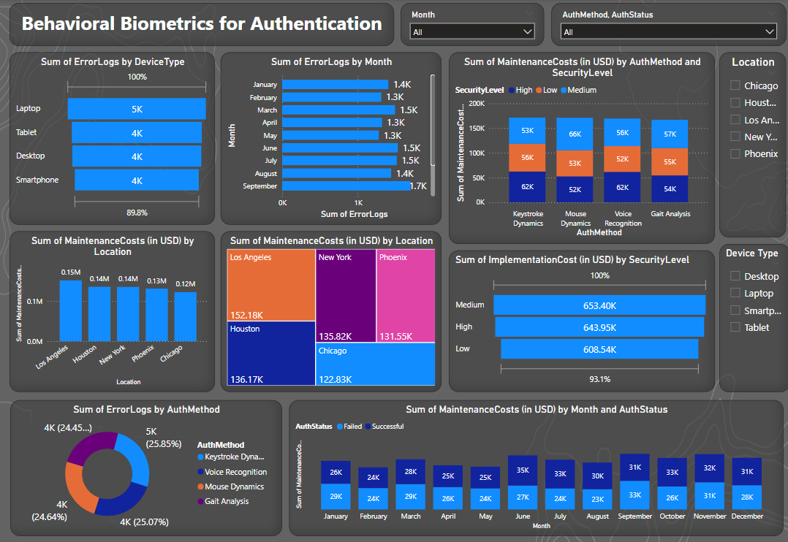

## 2. Blockchain Implementation for Security

3. Digital Banking Adoption Analysis  
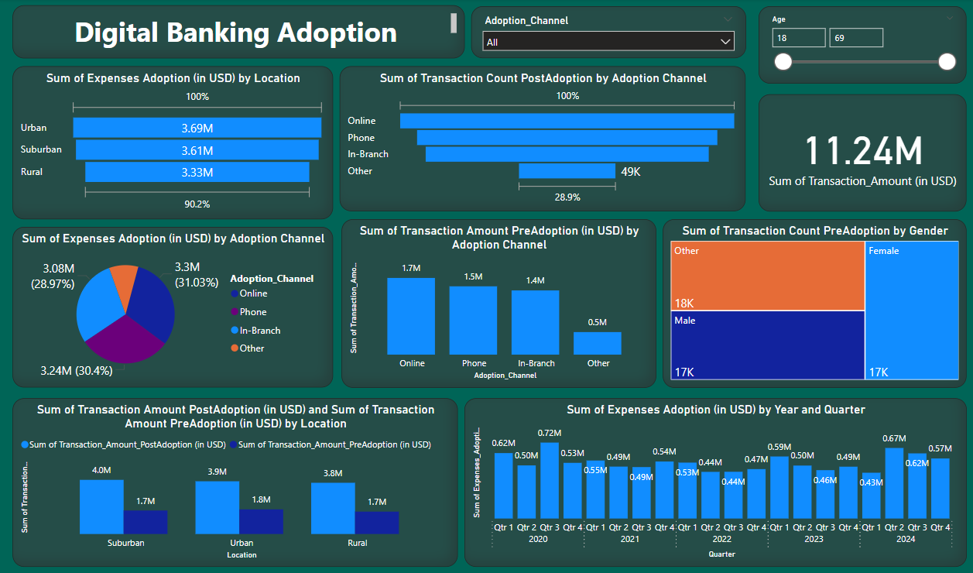

## 4. Mobile Banking App Analytics

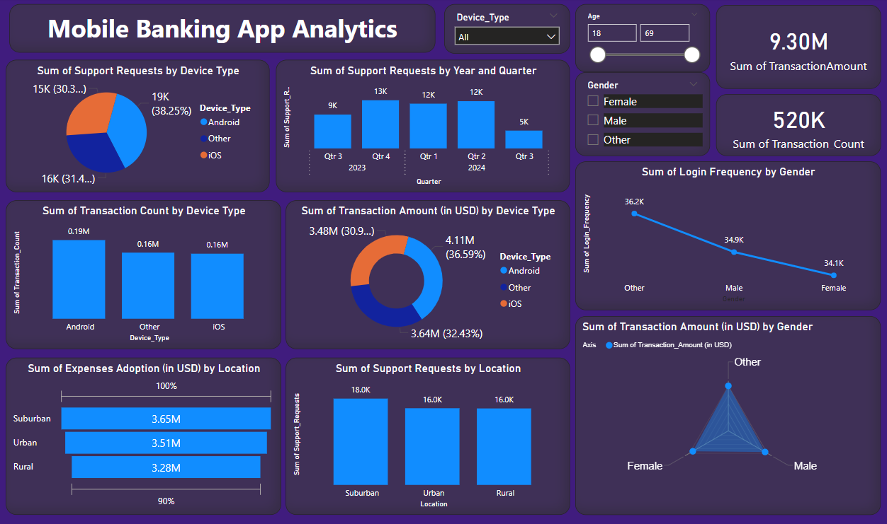

## 5. Predictive Maintenance for ATMs

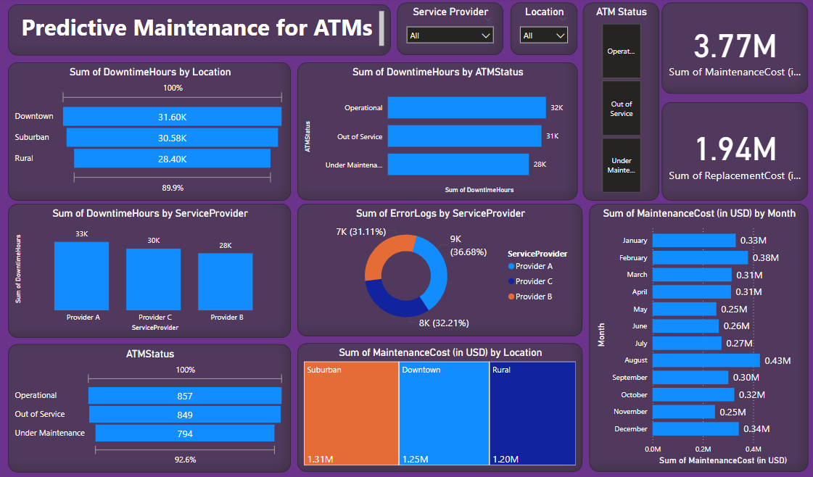

# Results:

## Summary Dashboard

**Insights:**

* High Costs in Medium Security Levels: Both Blockchain Implementation and Behavioral Biometrics show that medium security levels incur higher costs.
* Increased Adoption Costs in Urban Areas: Digital Banking Adoption and Mobile Banking App Analytics indicate higher adoption expenses in urban areas.
* Significant Seasonal Variations: Error logs peak in certain quarters (Q4 2023) across different technologies, highlighting potential seasonal impacts or specific incidents.

## 1. Mobile Banking App Analytics

**Insights:**

* Android Issues and Peaks: Android devices have the most support requests and peak during specific quarters, indicating potential platform-specific issues and increased usage during those times.
* Suburban Focus: Suburban areas have the highest support requests and adoption expenses, highlighting the need for targeted service and investment in these regions.
* User Engagement: Users categorized as Other have the highest login frequency, and male users log in slightly more often than female users, reflecting different engagement levels.
* Transaction Dynamics: There’s a notable increase in transaction counts and amounts after adoption, especially through Android devices, with balanced transaction amounts across genders.

## 2. Predictive Maintenance for ATMs

**Insights:**

* ATMs in downtown and urban areas experience the highest downtime, leading to significant maintenance costs.
* Network-related issues are the most common, contributing to the majority of downtime hours.
* Service providers differ in efficiency, with some showing quicker resolution times and fewer error logs, highlighting the importance of choosing reliable partners.

## 3. Behavioral Biometrics for Authentication

**Insights:**

* Laptops and desktops have the highest number of error logs, particularly with Voice Recognition authentication.
* Maintenance costs are highest in Los Angeles and Houston, with medium security levels incurring the most significant expenses.
* Implementation costs are notably higher for medium security levels compared to high and low security levels.

## 4. Blockchain Implementation for Security

**Insights:**

* Transaction amounts are evenly distributed among transfers, withdrawals, and deposits.
* Medium security levels incur the highest security costs, with locations like New York and Phoenix having the highest training costs.
* Maintenance costs are highest during the deployment phase, emphasizing the need for efficient deployment strategies.
* Error logs peak in December and are lowest in August, indicating seasonal variations in system performance.

## 5. Digital Banking Adoption Analysis

**Insights:**

* Urban areas lead in adoption expenses at $3.69M, with online channels having the highest costs.
* Post-adoption, online channels see the highest increase in transaction counts and amounts.
* Users show a strong preference for online ($1.7M) and phone ($1.5M) channels even before adopting digital banking.
* Female users have the highest transaction counts before adopting digital banking.
* Suburban areas see the highest post-adoption transaction amounts ($4.0M), followed by urban ($3.9M) and rural ($3.8M) areas.

# Summary of this Analysis:

1. **Mobile Banking App Analytics**: Users identified as ‘Other’ log in most frequently, with males slightly more active than females, suggesting demographic-based engagement differences.
2. **Predictive Maintenance for ATMs**: Downtown and urban ATMs face the highest downtime and maintenance costs, indicating a need for better maintenance strategies in these areas.
3. **Behavioral Biometrics for Authentication**: Laptops and desktops show the most error logs with Voice Recognition, highlighting the need for improved authentication security.
4. **Blockchain Implementation for Security**: Maintenance costs peak during blockchain deployment, emphasizing the need for efficient deployment strategies.
5. **Digital Banking Adoption Analysis**: Post-adoption, online channels see the highest growth in transactions, underscoring the need for robust digital banking platforms.